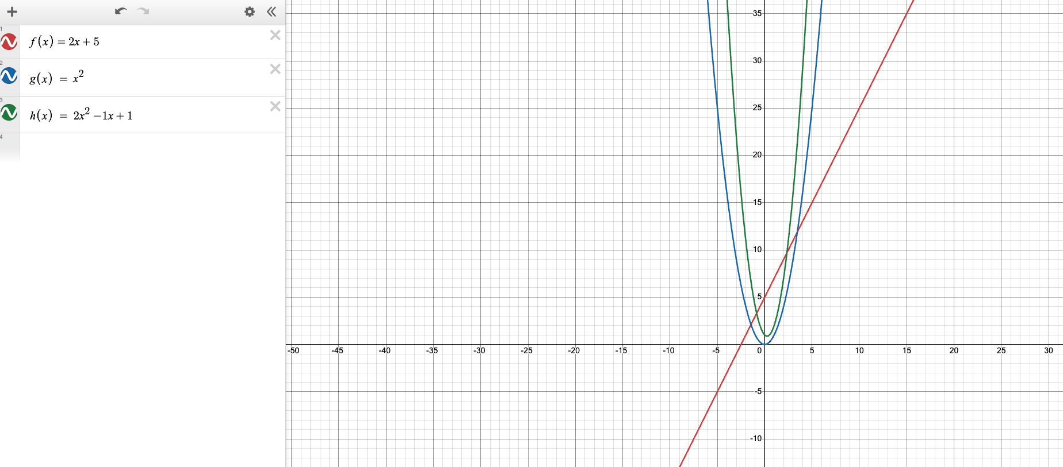
1) The coefficient affects the tilt(gradient) of the line, and the constant(y-intercept) moves the line up and down

2) The term(power) makes the arc of the line, making it constant, linear, quadratic, cubic, quartic, quintic, etc.

3)The coefficient affects the thickness or thinness of the arc(as it non-linear), and the linear term(-2x) moves it left and right, while the constant moves it up and down

